1. 2 Queens problem

CODE:

*def* is_safe(*board*, *row*, *col*):

    for i in range(*row*):

        if *board*[i][*col*] == 'Q' or *board*[i][*row* - i] == 'Q':

            return False

    return True

*def* solve_queens(*n*):

    if *n* != 2:

        print("The 2x2 Queens Problem is not solvable.")

        return

    board = [['.' for _ in range(*n*)] for _ in range(*n*)]

    if solve(board, 0, *n*):

        for row in board:

            print(' '.join(row))

    else:

        print("No solution exists.")

*def* solve(*board*, *row*, *n*):

    if *row* == *n*:

        return True

    for col in range(*n*):

        if is_safe(*board*, *row*, col):

*board*[*row*][col] = 'Q'

            if solve(*board*, *row* + 1, *n*):

                return True

*board*[*row*][col] = '.'

    return False

if __name__ == "__main__":

    solve_queens(2)

OUTPUT

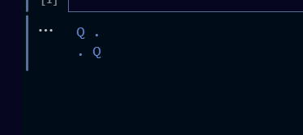

1. 8 Queens problem

Code

*def* is_safe(*board*, *row*, *col*):

    # Check the left side of the current row

    for i in range(*col*):

        if *board*[*row*][i] == 1:

            return False

    # Check upper diagonal on the left side

    for i, j in zip(range(*row*, -1, -1), range(*col*, -1, -1)):

        if *board*[i][j] == 1:

            return False

    # Check lower diagonal on the left side

    for i, j in zip(range(*row*, len(*board*), 1), range(*col*, -1, -1)):

        if *board*[i][j] == 1:

            return False

    return True

*def* solve_queens(*board*, *col*):

    if *col* >= len(*board*):

        return True

    for i in range(len(*board*)):

        if is_safe(*board*, i, *col*):

*board*[i][*col*] = 1

            if solve_queens(*board*, *col* + 1):

                return True

*board*[i][*col*] = 0

    return False

*def* print_solution(*board*):

    for row in *board*:

        print(" ".join(["Q" if x else "." for x in row]))

*def* solve_8_queens():

    board = [[0] * 8 for _ in range(8)]

    if solve_queens(board, 0):

        print_solution(board)

    else:

        print("No solution exists.")

if __name__ == "__main__":

    solve_8_queens()

output:  
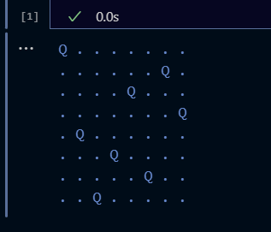

3)Python Program for Water Jug Problem

Code

from collections import deque

def water_jug_problem(capacity_x, capacity_y, target):

    visited = set()

    initial_state = (0, 0)  # Initial state with both jugs empty

    queue = deque([initial_state])

    while queue:

        current_state = queue.popleft()

        x, y = current_state

        if x == target or y == target:

            return current_state

        # Define possible actions: Fill jug x, fill jug y, empty jug x, empty jug y, pour from x to y, pour from y to x

        actions = [

            (capacity_x, y),

            (x, capacity_y),

            (0, y),

            (x, 0),

            (min(x + y, capacity_x), max(0, x + y - capacity_x)),

            (max(0, x + y - capacity_y), min(x + y, capacity_y))

        ]

        for action in actions:

            if action not in visited:

                queue.append(action)

                visited.add(action)

    return None  # If no solution is found

def print_solution(solution, capacity_x, capacity_y):

    if solution:

        x, y = solution

        print("Solution:")

        print(f"Jug X: {x}/{capacity_x}")

        print(f"Jug Y: {y}/{capacity_y}")

    else:

        print("No solution exists.")

if __name__ == "__main__":

    capacity_x = 4  # Capacity of jug X

    capacity_y = 3  # Capacity of jug Y

    target = 2  # Desired amount of water

    solution = water_jug_problem(capacity_x, capacity_y, target)

    print_solution(solution, capacity_x, capacity_y)

OUTPUT:

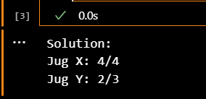

4)Python Program for Crypt-Arithmatic Problem

Code:

import itertools

def is_valid_solution(words, mapping):

    values = []

    for word in words:

        value = 0

        for letter in word:

            value = value * 10 + mapping[letter]

        values.append(value)

    return all(values[0] + values[1] == values[2] for values in itertools.permutations(values))

def solve_cryptarithmetic(words):

    # Extract all unique letters from the words

    unique_letters = set("".join(words))

    # Check if the words have the same length, if not, no solution is possible

    if len(unique_letters) > 10 or len(words[0]) < len(words[-1]):

        return None

    for perm in itertools.permutations("0123456789", len(unique_letters)):

        mapping = dict(zip(unique_letters, perm))

        if is_valid_solution(words, mapping):

            return mapping

    return None

if __name__ == "__main__":

    word1 = "SEND"

    word2 = "MORE"

    result_word = "MONEY"

    words = [word1, word2, result_word]

    solution = solve_cryptarithmetic(words)

    if solution:

        print("Solution found:")

        for word in words:

            print("".join(str(solution[letter]) for letter in word))

    else:

        print("No solution exists.")

OUTPUT

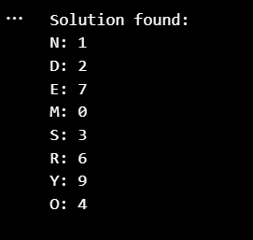

5) Write the python program for Missionaries Cannibal problem

Code:

from collections import deque

# Define the initial and goal states

initial_state = (3, 3, 1)  # (Missionaries on the left, Cannibals on the left, Boat on the left)

goal_state = (0, 0, 0)

# Define valid actions

valid_actions = [(1, 0), (2, 0), (0, 1), (0, 2), (1, 1)]

def is_valid(state):

    m, c, b = state

    if m < 0 or c < 0 or m > 3 or c > 3 or (m != 0 and m < c) or (m != 3 and 3 - m < 3 - c):

        return False

    return True

def get_neighbors(state):

    neighbors = []

    for action in valid_actions:

        if state[2] == 1:  # Boat is on the left

            new_state = tuple(state[i] - action[i] if i < 2 else 1 - state[i] for i in range(3))

        else:  # Boat is on the right

            new_state = tuple(state[i] + action[i] if i < 2 else 1 - state[i] for i in range(3))

        if is_valid(new_state) and new_state != state:

            neighbors.append(new_state)

    return neighbors

def solve_missionaries_and_cannibals():

    visited = set()

    queue = deque([(initial_state, [])])

    while queue:

        state, path = queue.popleft()

        if state == goal_state:

            return path

        for neighbor in get_neighbors(state):

            if neighbor not in visited:

                visited.add(neighbor)

                new_path = path + [state, neighbor]

                queue.append((neighbor, new_path))

    return None

def print_solution(solution):

    if solution:

        print("Solution:")

        for state in solution:

            print(f"Missionaries: {state[0]}, Cannibals: {state[1]}, Boat: {'Left' if state[2] == 1 else 'Right'}")

    else:

        print("No solution exists.")

if __name__ == "__main__":

    solution = solve_missionaries_and_cannibals()

    print_solution(solution)

OUTPUT

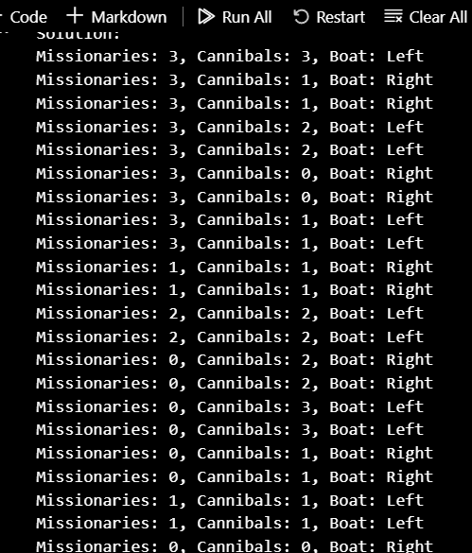

6) Write the python program for Vacuum Cleaner problem

class VacuumCleaner:

    def __init__(self, grid):

        self.grid = grid

        self.rows = len(grid)

        self.cols = len(grid[0])

        self.row = 0

        self.col = 0

    def clean(self):

        while True:

            self.clean_current_cell()

            if not self.move_to_next_cell():

                break

    def clean_current_cell(self):

        if self.grid[self.row][self.col] == 1:

            print(f"Cleaning cell at row {self.row}, col {self.col}")

            self.grid[self.row][self.col] = 0

    def move_to_next_cell(self):

        if self.row < self.rows - 1:

            self.row += 1

        elif self.col < self.cols - 1:

            self.row = 0

            self.col += 1

        else:

            return False

        return True

if __name__ == "__main__":

    # Define a grid where 1 represents a dirty cell

    grid = [[1, 0, 1],

            [0, 1, 0],

            [1, 0, 1]]

    # Create a vacuum cleaner agent and start cleaning

    vacuum = VacuumCleaner(grid)

    vacuum.clean()

OUTPUT:

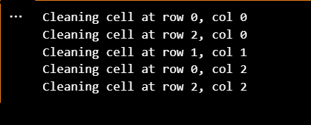

7) Write the python program to implement BFS.

CODE:

from collections import defaultdict, deque

class Graph:

    def __init__(self):

        self.graph = defaultdict(list)

    def add_edge(self, vertex, neighbor):

        self.graph[vertex].append(neighbor)

    def bfs(self, start_vertex):

        visited = set()

        queue = deque()

        visited.add(start_vertex)

        queue.append(start_vertex)

        while queue:

            current_vertex = queue.popleft()

            print(current_vertex, end=" ")

            for neighbor in self.graph[current_vertex]:

                if neighbor not in visited:

                    visited.add(neighbor)

                    queue.append(neighbor)

if __name__ == "__main__":

    # Create a graph

    g = Graph()

    g.add_edge(0, 1)

    g.add_edge(0, 2)

    g.add_edge(1, 2)

    g.add_edge(2, 0)

    g.add_edge(2, 3)

    g.add_edge(3, 3)

    start_vertex = 2  # Starting vertex for BFS

    print("Breadth-First Traversal (starting from vertex", start_vertex, "):")

    g.bfs(start_vertex)

OUTPUT:  
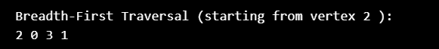

8) Write the python program to implement DFS

CODE:

from collections import defaultdict

class Graph:

    def __init__(self):

        self.graph = defaultdict(list)

    def add_edge(self, vertex, neighbor):

        self.graph[vertex].append(neighbor)

    def dfs(self, start_vertex, visited):

        visited.add(start_vertex)

        print(start_vertex, end=" ")

        for neighbor in self.graph[start_vertex]:

            if neighbor not in visited:

                self.dfs(neighbor, visited)

if __name__ == "__main__":

    # Create a graph

    g = Graph()

    g.add_edge(0, 1)

    g.add_edge(0, 2)

    g.add_edge(1, 2)

    g.add_edge(2, 0)

    g.add_edge(2, 3)

    g.add_edge(3, 3)

    start_vertex = 2  # Starting vertex for DFS

    visited = set()

    print("Depth-First Traversal (starting from vertex", start_vertex, "):")

    g.dfs(start_vertex, visited)

OUTPUT:

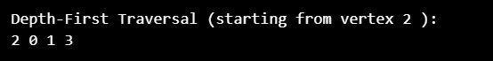

9)Travelling salesman Problem to find the shortest distance using python

CODE:

import itertools

def calculate_total_distance(path, distances):

    total_distance = 0

    for i in range(len(path) - 1):

        total_distance += distances[path[i]][path[i+1]]

    total_distance += distances[path[-1]][path[0]]  # Return to the starting city

    return total_distance

def traveling_salesman_bruteforce(distances):

    num_cities = len(distances)

    cities = list(range(num_cities))

    shortest_path = None

    shortest_distance = float('inf')

    for path in itertools.permutations(cities):

        distance = calculate_total_distance(path, distances)

        if distance < shortest_distance:

            shortest_path = path

            shortest_distance = distance

    return shortest_path, shortest_distance

if __name__ == "__main__":

    # Example: Distances between cities

    distances = [

        [0, 29, 20, 21],

        [29, 0, 15, 22],

        [20, 15, 0, 24],

        [21, 22, 24, 0]

    ]

    shortest_path, shortest_distance = traveling_salesman_bruteforce(distances)

    print("Shortest path:", shortest_path)

    print("Shortest distance:", shortest_distance)

OUTPUT:  
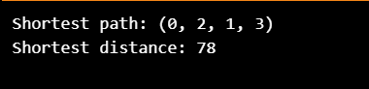

10) Write the python program to implement A* algorithm

import heapq

class Node:

    def __init__(self, x, y, parent=None):

        self.x = x

        self.y = y

        self.parent = parent

        self.g = 0

        self.h = 0

    def __lt__(self, other):

        return (self.g + self.h) < (other.g + other.h)

def heuristic(node, goal):

    return abs(node.x - goal.x) + abs(node.y - goal.y)

def astar(grid, start, goal):

    open_set = []

    closed_set = set()

    start_node = Node(start[0], start[1])

    goal_node = Node(goal[0], goal[1])

    heapq.heappush(open_set, start_node)

    while open_set:

        current_node = heapq.heappop(open_set)

        if current_node.x == goal_node.x and current_node.y == goal_node.y:

            path = []

            while current_node:

                path.append((current_node.x, current_node.y))

                current_node = current_node.parent

            return path[::-1]

        closed_set.add((current_node.x, current_node.y))

        for dx, dy in [(0, 1), (0, -1), (1, 0), (-1, 0)]:

            new_x, new_y = current_node.x + dx, current_node.y + dy

            if 0 <= new_x < len(grid) and 0 <= new_y < len(grid[0]) and grid[new_x][new_y] != 1:

                if (new_x, new_y) not in closed_set:

                    child_node = Node(new_x, new_y, parent=current_node)

                    child_node.g = current_node.g + 1

                    child_node.h = heuristic(child_node, goal_node)

                    heapq.heappush(open_set, child_node)

    return None

if __name__ == "__main__":

    # Example grid (0 represents empty, 1 represents an obstacle)

    grid = [

        [0, 0, 0, 0, 0],

        [0, 1, 1, 0, 0],

        [0, 1, 0, 0, 0],

        [0, 1, 0, 1, 0],

        [0, 0, 0, 0, 0]

    ]

    start = (0, 0)

    goal = (4, 4)

    path = astar(grid, start, goal)

    if path:

        print("Path found:", path)

    else:

        print("No path found.")

OUTPUT:  


11) Write the python program for Map Coloring to implement CSP.

CODE:

def is_valid_assignment(graph, assignment, node, color):

    for neighbor in graph[node]:

        if neighbor in assignment and assignment[neighbor] == color:

            return False

    return True

def backtracking(graph, colors, assignment, node):

    if node not in assignment:

        for color in colors:

            if is_valid_assignment(graph, assignment, node, color):

                assignment[node] = color

                if len(assignment) == len(graph):

                    return True

                next_node = get_unassigned_node(graph, assignment)

                if backtracking(graph, colors, assignment, next_node):

                    return True

                assignment.pop(node)

    return False

def get_unassigned_node(graph, assignment):

    for node in graph:

        if node not in assignment:

            return node

def map_coloring(graph, colors):

    assignment = {}

    start_node = get_unassigned_node(graph, assignment)

    if backtracking(graph, colors, assignment, start_node):

        return assignment

    else:

        return None

if __name__ == "__main__":

    # Define the graph (adjacency list)

    graph = {

        "WA": ["NT", "SA"],

        "NT": ["WA", "SA", "Q"],

        "SA": ["WA", "NT", "Q", "NSW", "V"],

        "Q": ["NT", "SA", "NSW"],

        "NSW": ["Q", "SA", "V"],

        "V": ["SA", "NSW"]

    }

    # Define the available colors

    colors = ["Red", "Green", "Blue"]

    # Solve the map coloring problem

    solution = map_coloring(graph, colors)

    if solution:

        print("Map coloring solution:")

        for node, color in solution.items():

            print(f"{node}: {color}")

    else:

        print("No solution exists.")

OUTPUT:

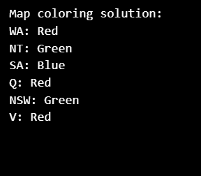

12) Write the python program for Tic Tac Toe game

CODE:

def print_board(board):

    for row in board:

        print(" | ".join(row))

        print("-" * 9)

def check_winner(board, player):

    for row in board:

        if all(cell == player for cell in row):

            return True

    for col in range(3):

        if all(row[col] == player for row in board):

            return True

    if all(board[i][i] == player for i in range(3)) or all(board[i][2 - i] == player for i in range(3)):

        return True

    return False

def is_board_full(board):

    return all(cell != " " for row in board for cell in row)

def play_tic_tac_toe():

    board = [[" " for _ in range(3)] for _ in range(3)]

    current_player = "X"

    while True:

        print_board(board)

        try:

            while True:

                row, col = map(int, input(f"Player {current_player}, enter row (0-2) and column (0-2) separated by space: ").split())

                if row not in [0, 1, 2] or col not in [0, 1, 2]:

                    print("Invalid input. Please enter numbers between 0 and 2.")

                    continue

                if board[row][col] == " ":

                    break

                else:

                    print("That cell is already taken. Try again.")

        except ValueError:

            print("Invalid input. Please enter numbers.")

            continue

        except Exception as e:

            print(f"An error occurred: {str(e)}")

            continue

        board[row][col] = current_player

        if check_winner(board, current_player):

            print_board(board)

            print(f"Player {current_player} wins!")

            break

        if is_board_full(board):

            print_board(board)

            print("It's a tie!")

            break

        current_player = "O" if current_player == "X" else "X"

if __name__ == "__main__":

    print("Welcome to Tic-Tac-Toe!")

    play_tic_tac_toe()

OUTPUT:  
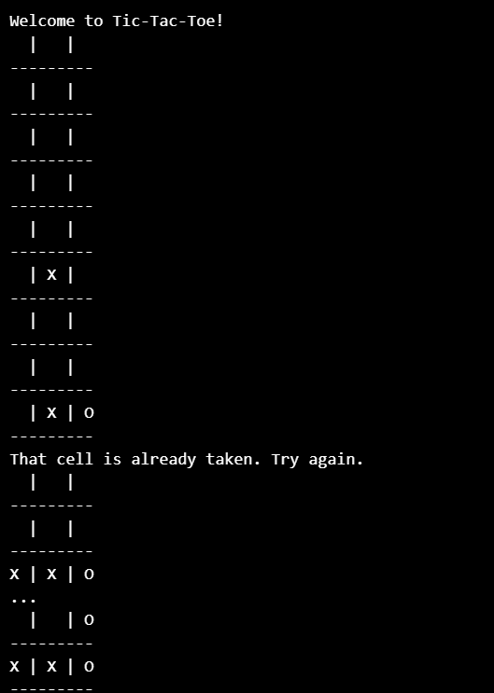

13) Write the python program to implement Minimax algorithm for gaming

CODE:  
def is_game_over(state):

    # Check if the game is over and return the winner or tie

    for row in state:

        if all(cell == 'X' for cell in row):

            return 'X'

        if all(cell == 'O' for cell in row):

            return 'O'

    for col in range(3):

        if all(state[row][col] == 'X' for row in range(3)):

            return 'X'

        if all(state[row][col] == 'O' for row in range(3)):

            return 'O'

    if all(state[i][i] == 'X' for i in range(3)) or all(state[i][2 - i] == 'X' for i in range(3)):

        return 'X'

    if all(state[i][i] == 'O' for i in range(3)) or all(state[i][2 - i] == 'O' for i in range(3)):

        return 'O'

    if all(cell != ' ' for row in state for cell in row):

        return None  # It's a tie

    return False  # Game is not over

def get_valid_moves(state):

    # Return a list of valid moves (empty cells) from the given state

    moves = []

    for row in range(3):

        for col in range(3):

            if state[row][col] == ' ':

                moves.append((row, col))

    return moves

def make_move(state, move, player):

    # Return a new state after applying the move to the given state

    new_state = [row.copy() for row in state]

    new_state[move[0]][move[1]] = player

    return new_state

def minimax(state, player):

    winner = is_game_over(state)

    if winner is not False:

        if winner == 'X':

            return 1

        elif winner == 'O':

            return -1

        else:  # Tie

            return 0

    moves = get_valid_moves(state)

    if player == 'X':

        best_score = float('-inf')

        for move in moves:

            new_state = make_move(state, move, player)

            score = minimax(new_state, 'O')

            best_score = max(score, best_score)

        return best_score

    else:  # player == 'O'

        best_score = float('inf')

        for move in moves:

            new_state = make_move(state, move, player)

            score = minimax(new_state, 'X')

            best_score = min(score, best_score)

        return best_score

# Example usage

if __name__ == "__main__":

    board = [['X', ' ', 'O'],

             ['O', 'X', ' '],

             ['X', 'O', ' ']]

    player = 'X'

    print("The Tic-Tac-Toe board state:")

    for row in board:

        print(" | ".join(row))

        print("-" * 9)

    score = minimax(board, player)

    print(f"The score for player {player} is: {score}")

output

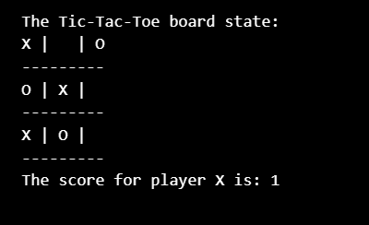

14)Write the python program to implement Apha & Beta pruning algorithm for gaming

# Python3 program to demonstrate

# working of Alpha-Beta Pruning

# Initial values of Alpha and Beta

MAX, MIN = 1000, -1000

# Returns optimal value for current player

#(Initially called for root and maximizer)

def minimax(depth, nodeIndex, maximizingPlayer,

            values, alpha, beta):

    # Terminating condition. i.e

    # leaf node is reached

    if depth == 3:

        return values[nodeIndex]

    if maximizingPlayer:

        best = MIN

        # Recur for left and right children

        for i in range(0, 2):

            val = minimax(depth + 1, nodeIndex * 2 + i,

                          False, values, alpha, beta)

            best = max(best, val)

            alpha = max(alpha, best)

            # Alpha Beta Pruning

            if beta <= alpha:

                break

        return best

    else:

        best = MAX

        # Recur for left and

        # right children

        for i in range(0, 2):

            val = minimax(depth + 1, nodeIndex * 2 + i,

                            True, values, alpha, beta)

            best = min(best, val)

            beta = min(beta, best)

            # Alpha Beta Pruning

            if beta <= alpha:

                break

        return best

# Driver Code

if __name__ == "__main__":

    values = [3, 5, 6, 9, 1, 2, 0, -1]

    print("The optimal value is :", minimax(0, 0, True, values, MIN, MAX))

# This code is contributed by Rituraj Jain

OUTPUT:

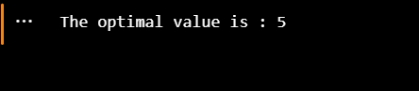

15)Write the python program to implement Decision Tree

CODE:

OUTPUT:

16) Write the python program to implement Feed forward neural Network

CODE:

OUTPUT: